



Subject IICT

Topic Ports and Connectors

Submitted to Sir Arsalan Aftab

Submitted By 20SW015

Batch 20SW

Dpartment SoFTware Engineering

EXERCISE

1 What are different ports and connectors do you find int lab? for each ,in the following table.

|  |  |  |  |  |  |  |  |  |  |  |  |  |  |  |  |  |  |  |  |  |  |  |  |  |  |  |  |  |  |  |  |  |  |  |  |  |  |  |  |  |  |  |  |  |  |  |  |  |  |  |  |  |  |  |  |  |  |  |  |  |  |  |  |  |  |
| --- | --- | --- | --- | --- | --- | --- | --- | --- | --- | --- | --- | --- | --- | --- | --- | --- | --- | --- | --- | --- | --- | --- | --- | --- | --- | --- | --- | --- | --- | --- | --- | --- | --- | --- | --- | --- | --- | --- | --- | --- | --- | --- | --- | --- | --- | --- | --- | --- | --- | --- | --- | --- | --- | --- | --- | --- | --- | --- | --- | --- | --- | --- | --- | --- | --- |
| |  |  |  |  |  | | --- | --- | --- | --- | --- | | Ports and Connetctors | | Number of pins | Device attached to | | | DIN  (duetsches institute fur normung) | | 5 Pins | PC keyboard, MIDI keyboard,Electronic instruments | | | PS/2  ( personal system) | | 6 Pins | (purple) keyboard connector  (green) Mouse connector | | | Serial Port | | 9 pins | Printers, mice | | | Prallel port | | 25 Pins | Printers Connector | | | VGA  (video graphics array) | | 15 pins | Video cards , Computer monitors,  High deffination television | | | USB  (Universal Serial Bus) | | 4 pins | Transfer of Data from one device to another device | | | Auto Ports | | 3 main pins | Mic(purple) , line in(headphone)(Green),Line Out(speakers)(Blue) | | | RJ - 11(rigister Jack) | 6 pins (Wires ) | | | Phone jack , Phone connector,Phone line. | | RJ -45(Rigister Jack) | 8 pins | | | Enternet Networks | | S/PDIF(Sony and Phillips digital increment format | 1 pin | | | Digital Audio signal transmit | | HDMI(High deffination Multimedia Interface | 8 channels | | | All Digital video and audio Interface | | DVI(Digital visual interface) | 24 pins | | | Connector of digital Monitor |   S - video(Super video) 4 pins Use to dividing the video one for bright-  ness and othe for luminus |
|  |

2 Identify and label the ports in the mother board as below.

RJ -45

USB -A

VGA Port

USB-A

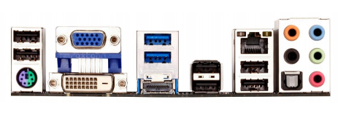

S/PDIF

DVI(digital visual interface

Sp/2

USB-A

Firewire port

HDMI

USB-A

3 Identify and label the ports shown in motherboard.

VGA

SP/2

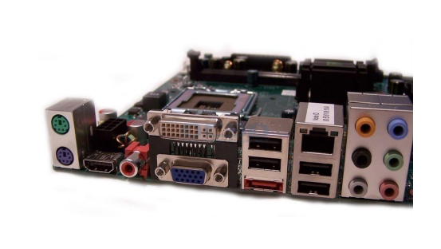

S/PDIF

HDMI

DVI

RJ - 45

Microphone

USB - A

**4 Identify and label the ports as shown in motherboard .**

VGA

RJ-45

Firewire

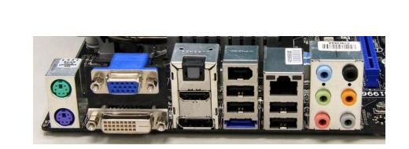

S/PDIF

SP/2

(Mouse)

SP/2

(keybosrd )

DVI

USB-A

HDMI

**5- Describe the function of each of pins.**

**USB PORT**

|  |  |
| --- | --- |
| Pin number | Function |
| Pin 1 | +5v means give Power to USB |
| Pin 2 | Data - Means carries data |
| Pin 3 | Data+means Caries data |
| Pin 4 | Ground provides means 0v |

**SP/2 Port**

|  |  |
| --- | --- |
| **Pins number** | **Function** |
| Pin 1 | It is keyboard data ,it carries data signal from keyboard to system unit. |
| Pin 2 | It is not used. |
| Pin 3 | It is Provides the ground (0v) |
| Pin 4 | it is provide a power to keyboard(+5v) |
| Pin 5 | It is keyboard clock signals, synchronizes the keyboard with system unit. |
| Pin 6 | It is not used. |

**Serial ports**

|  |  |
| --- | --- |
| **Pin number** | **Function** |
| Pin 1 | work as a Data carrier detect(DCD) |
| Pin 2 | Receive Data (RXD) |
| Pin 3 | Transmit data (TXD) |
| Pin 4 | Data terminal ready (DTR) |
| Pin 5 | Ground |
| Pin 6 | Data set ready(DSR) |
| Pin 7 | Request to send(RTS) |
| Pin 8 | Clear to send(CTS) |
| Pin 9 | Ring inductor(RI) |

**RJ-11**

|  |  |
| --- | --- |
| Pin number | function |
| Pin 1 | No Connection |
| Pin 2 | Ground |
| Pin 3 | Transmit data from power volt |
| Pin 4 | Receive data to power volt |
| Pin 5 | Report to send |
| Pin 6 | Clear to send |

**RJ-45**

|  |  |
| --- | --- |
| Pin number | Function |
| Pin 1 | Transmit Data (+ ) |
| Pin 2 | Transmit Data (-) |
| Pin 3 | Receive Data(+) |
| Pin 4 | Not used |
| Pin 5 | Not used |
| Pin 6 | Receive Data (-) |
| Pin 7 | Not used |
| Pin 8 | Not used |

**Firewire Ports**

|  |  |
| --- | --- |
| Pin number | function |
| Pin 1 | Power (30 vol) |
| Pin 2 | Ground |
| Pin 3 | Twisted pair B-(send data) |
| Pin 4 | Twisted pair B+(send) |
| Pin 5 | Twisted pair A-(receive data) |
| Pin 6 | Twistted piar A+(receive) |

**S- Video Out Port**

|  |  |
| --- | --- |
| Pin number | Function |
| Pin 1 | Ground (Y) |
| Pin 2 | Ground(C) |
| Pin 3 | Intensity (luminance) |
| Pin 4 | Color(Chrominance) |

**S-Video in port**

|  |  |
| --- | --- |
| Pin number | Function |
| Pin 1 | Ground(Y) |
| Pin 2 | Ground(C) |
| Pin 3 | Intensity(luminance) |
| Pin 4 | Color (chrominsnce) |
| Pin 5 | Composite Ground |
| Pin 6 | Not used |
| Pin 7 | Composite Video |